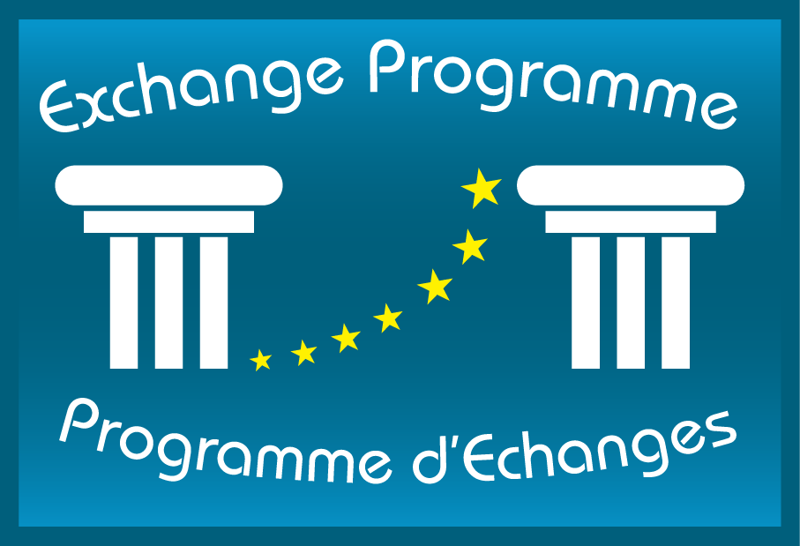

European Judicial Training Network
Réseau Européen de Formation Judiciaire

PRACTICAL GUIDE TO THE EXCHANGE PROGRAMME FOR JUDICIAL AUTHORITIES

January 2014

With the support of the European Union

TABLE OF CONTENTS

I. BACKGROUND 3
II. TYPES OF ACTIVITIES 5
III. SELECTION PROCEDURE 12
IV. BEFORE, DURING AND AFTER THE ACTIVITY 13
V. FINANCIAL CONDITIONS 14
VI. CONTACTS 19

BACKGROUND

The European Judicial Training Network
Founded on 13th October 2000, the European Judicial Training Network (EJTN) is a non-profit making international organisation (AISBL) with its headquarters in Brussels and comprises the institutions specifically responsible for the training of the professional judiciary within the European Union (EU). It currently has 34 members from the 28 Member States of the European Union and 11 observers amongst which the institutions of the European Union and the Council of Europe.
EJTN aims to initiate and develop training programmes with a genuine European dimension for members of the European judiciary. This involves analysing and identifying training needs, designing programmes and methods for collaborative training, developing exchanges and sharing experiences in the field of judicial training, coordinating programmes and providing training expertise and know-how.
In order to carry out its activities, EJTN has established a permanent secretariat in Brussels. For more information on EJTN and its activities, you can visit the EJTN website at www.ejtn.eu .

The Exchange Programme
Launched at the initiative of the European Parliament and funded for the tenth consecutive year by the European Commission, the main objective of the Exchange Programme is to develop mutual trust between judicial authorities and the feeling of belonging to a common European judicial area in order to promote the mutual recognition of judicial decisions by getting to know each other better and working together.
The first Exchange Programme was implemented in 2005 by two members of EJTN (the French National School for the Magistracy and the Italian High Council for the Magistracy). Since 2006, EJTN is itself in charge of its implementation. The same year, it has been recognised a de facto monopoly in the implementation of the Exchange Programme by the European Commission.
Since the implementation of the first Exchange Programme, approximately 5,550 judges and prosecutors (including futures judges and prosecutors), judicial trainers and members of Councils for the Judiciary have participated in an exchange. The number of exchanges and partners has gradually increased since the first year of implementation.

In 2014, EJTN will implement the Exchange Programme in partnership with 34 institutions from 24 different countries. Within EJTN, 5 persons are in charge of the implementation of the Programme.

Number of participants 2010-2014
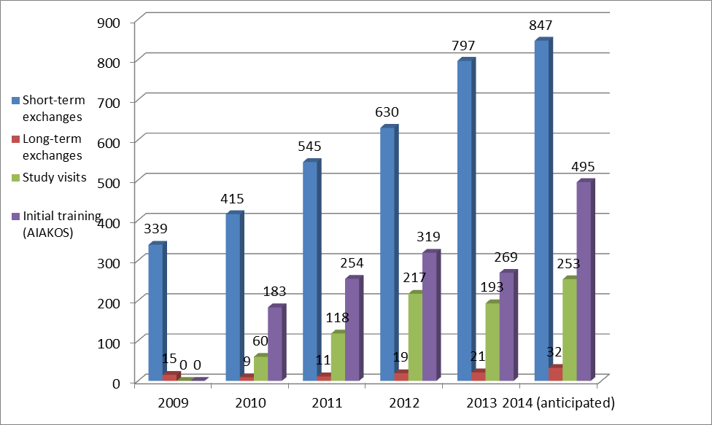

Different kinds of activities are proposed depending on the length, the number of participants and their functions (see section II for more information).

Breakdown of participants by category
(Exchange Programme implemented in 2012)

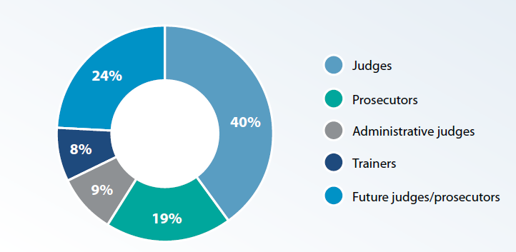

TYPES OF ACTIVITIES
The general requirements for all the exchanges are the following:
- strong professional motivation
- good knowledge of the language required to take part in the activity

  - Short term exchanges

For judges and prosecutors

The main objective of this type of exchanges is to enable the participants to share the work of their counterparts in another EU country or candidate country, to familiarise themselves with a judicial system other than their own, to understand how it works and thus to assess their own professional practice. These exchanges are organised under two schemes:

- One-to-one (individual) exchanges
Description: the visiting judge/prosecutor shadows a counterpart in his/her daily practice in a court/prosecutor’s office of the host country. The judge/prosecutor may attend court hearings, examine files and be able to discuss cases with colleagues in the host jurisdiction… In most cases, one-to-one exchanges take place in the official language of the host country (see table p.7 for available language(s) by country).
Length: 2 weeks (10 working days)
Persons concerned: judges and prosecutors from 1st and 2nd instance ordinary and administrative courts (including future judges and prosecutors)

- Group exchanges
Description: the visiting judge/prosecutor is hosted in the host country with a group of judges/prosecutors from other EU/candidate countries. In the majority of cases, group exchanges are organised in a language other than that of the host country (usually English or French - see table p.7 for available language(s) by country). The general schedule is that, during the 1st week, the group of participants is introduced to the judicial system of the host country whereas during the 2nd week, it is separated into several courts/prosecution offices for more specific activities.
Length: 2 weeks (10 working days)
Persons concerned: judges and prosecutors from 1st and 2nd instance ordinary and administrative courts (including future judges and prosecutors)

For trainers
Description: judicial trainers are hosted by a judicial training institution of another country. They are involved in initial/continuous judicial training sessions devoted to judges/prosecutors and become familiar with the following: training methodologies, pedagogical tools, training programmes, best practice and any training initiative which applies in the host country. Judicial trainers can take part to “one to one exchanges” and/or to “group exchanges”. The exchange takes place either in the official language of the host country or in a common language (see table p.10 for available language(s) by country)
Length: from 1 to 2 week(s)
Persons concerned: judicial trainers for initial or continuous training, at national or decentralised level.

- Long-term training periods

Description: Long term training periods are organised at Eurojust, at the Court of Justice of the European Union and at the European Court of Human Rights. The participants will be assigned to the office of a National Member (Eurojust), to the Cabinet of a Member of the Court (CJEU) or to the Registry (ECHR) and they will help them carrying the tasks assigned to them. They will therefore get acquainted with the work, procedures and decision of these Europe-wide bodies. Once back in their country, they might be asked to disseminate the knowledge gained during the training period by participating in national events.
Length: 3 months at Eurojust, from 6 to 12 months at the Court of Justice of the European Union and 12 months at the European Court of Human Rights.
Persons concerned:
At Eurojust, the participant must be a practicing prosecutor or judge (preferably investigative judge) in an EU Member State, work at a national level where rogatory letters and other forms of judicial cooperation in criminal matters are dealt with and have at least three years of practical experience in the field of criminal law.
At the Court of Justice of the European Union, the participant must be a judge or a prosecutor from an EU Member State, have at least one year of experience as a judge/prosecutor, be familiar with Community law and have a good knowledge of French as well as of another EU language.
At the European Court of Human Rights, the participant must be a judge (either ordinary or administrative) or a prosecutor, have between 7 and 10 years of professional experience and have a perfect command of French or English.

- Study visits

European bodies
Description: study visits in European bodies such as the European Court of Human Rights, the Court of Justice of the European Union and Eurojust are designed to familiarise the participants with the visited institution through theoretical sessions as well as more practical activities. Study visits take place in either English or French.
Length: from 2 days to 1 week (4/5 days)
Persons concerned: judges and prosecutors from 1st and 2nd instance ordinary and administrative courts (including future judges and prosecutors) as well as Supreme Court judges.

AIAKOS (Initial training)
Description: future judges and prosecutors in initial training learn about their counterparts’ training and recruitment systems as well as about the judicial organisation and procedures of their host country. They attend real hearings and perform mock trials on law issues that are common to them.
Length: 1 week
Persons concerned: future judges and prosecutors in initial training.

List of participating countries and training languages – Judges and Prosecutors
Hosting country | Public | Available place(s) | Type of exchange | Length | Working language(s)
Austria | Judges (ordinary courts)/prosecutors | 20 | Group | 2 weeks | German/English
Austria | Administrative judges | 4 | Individual | 2 weeks | German/English
Belgium | Judges (ordinary courts)/prosecutors | 20 | Individual | 2 weeks | French/Dutch
Bulgaria | Judges/admin.judges/prosecutors | 21 | Group | 2 weeks | English
Croatia | Judges (ordinary courts)/prosecutors | 9 | Group | 2 weeks | English/Croatian
Czech Republic | Judges/admin.judges/prosecutors | 5 | Group | 2 weeks | Czech/English
Denmark | Judges (ordinary courts) | 6 | Group | 2 weeks | English
Estonia | Judges/admin.judges | 3 | Group | 2 weeks | English
Estonia | Prosecutors | 6 | Group | 2 weeks | English
Finland | Judges/admin.judges/prosecutors | 8 | Group | 2 weeks | English
France | Judges/prosecutors | 45 | Individual | 2 weeks | French
France | Judges/prosecutors | 35 | Group | 2 weeks | English/French
France | Administrative judges | 12 | Individual | 2 weeks | French
Germany | Judges/admin.judges/prosecutors | 70 | Individual | 2 weeks | German/English
Germany | Judges/admin.judges/prosecutors | 79 | Group | 2 weeks | English/French/ German
Hungary | Judges/admin.judges | 6 | Individual | 2 weeks | Hungarian/English
Hungary | Judges/admin.judges | 6 | Group | 2 weeks | Hungarian/English
Hungary | Prosecutors | 2 | Individual | 2 weeks | English
Italy | Judges (ordinary courts) /prosecutors | 30 | Individual | 2 weeks | Italian
Italy | Judges (ordinary courts) /prosecutors | 70 | Group | 2 weeks | English/French
Italy | Administrative judges | 11 | Individual | 2 weeks | Italian/English/French/German/Spanish
Italy | Administrative judges | 14 | Group | 2 weeks | English
Latvia | Judges – Ordinary and Administrative courts | 7 | Group | 2 weeks | Latvian/English
Lithuania | Judges – Ordinary and Administrative courts | 6 | Group | 2 weeks | English
Luxembourg | Judges/admin.judges/prosecutors | 2 | Individual | 2 weeks | French
Netherlands | Judges/admin.judges/prosecutors | 28 | Group | 2 weeks | English
Poland | Judges/prosecutors | 10 | Individual | 2 weeks | Polish/English
Poland | Judges/prosecutors | 50 | Group | 2 weeks | English
Portugal | Judges/admin.judges/prosecutors | 10 | Individual | 2 weeks | Portuguese
Portugal | Judges/admin.judges/prosecutors | 10 | Group | 2 weeks | English
Romania | Judges/admin.judges/prosecutors | 82 | Group/individual | 2 weeks | Romanian/English/French
Slovakia | Judges/prosecutors | 6 | Individual | 2 weeks | Slovak/Czech/English/German/French
Slovakia | Judges/prosecutors | 6 | Group | 2 weeks | Slovak/Czech/English/German/French
Slovenia | Judges/admin.judges/prosecutors | 12 | Group | 2 weeks | Slovenian/English
Spain | Judges – Ordinary and Administrative courts | 55 | Individual | 2 weeks | Spanish
Spain | Judges – Ordinary and Administrative courts | 20 | Group | 2 weeks | English
Spain | Prosecutors | 18 | Individual | 2 weeks | Spanish
Spain | Prosecutors | 12 | Group | 2 weeks | English/Italian
Sweden | Judges/admin.judges/prosecutors | 6 | Individual | 2 weeks | English
UK (England & Wales) | Judges/admin.judges | 10 | Individual | 2 weeks | English

List of participating countries and training languages – Trainers
Hosting Country | Public | Available place(s) | Type of exchange | Length | Working language(s)
Austria | Trainers | 1 | Individual | 1 week | German/English
Belgium | Trainers | 1 | Individual | 1 week | French/Dutch
Bulgaria | Trainers | 3 | Group | 1 week | English
Croatia | Trainers | 1 | Individual | 1 week | English
Czech Republic | Trainers | 2 | Group | 1 week | English
Estonia | Trainers | 3 | Group | 1 week | English
France | Trainers | 6 | Group | 1 week | French
Germany | Trainers | 6 | Individual | 1 week | English/ German/French
Italy | Trainers | 1 | Individual | 1 week | Italian
Italy | Trainers | 3 | Group | 1 week | English
Latvia | Trainers | 1 | Individual | 1 week | Latvian/English
Netherlands | Trainers | 2 | Group | 1 week | English
Poland | Trainers | 5 | Group | 1 week | English
Portugal | Trainers | 7 | Group | 1 week | English
Romania | Trainers | 6 | Group | 1 week | English
Slovakia | Trainers | 6 | Individual | 1 week | Slovak/Czech/English/German/French
Slovakia | Trainers | 5 | Group | 1 week | Slovak/Czech/English/German/French
Slovenia | Trainers | 1 | Individual | 1 week | English/Slovenian
Spain | Trainers | 5 | Group | 1 week | Spanish
UK – E&W | Trainers | 2 | Individual | 1 week | English
UK – Scotland | Trainers | 1 | Individual | 1 week | English
Academy of European Law (ERA) | Trainers | 3 | Individual | 1 week | English/French/German
Academy of European Law (ERA) | Trainers | 4 | Group | 1 week | English

SELECTION PROCEDURE
EJTN

Call for Applications

Partner institutions - contact points
DISSEMINATION OF
INFORMATION

Blank Application Form

Judges
Prosecutors
Trainers

Completed Application Forms

Partner institutions - contact points
PRESELECTION

Preselected Application Forms

EJTN
ALLOCATION
according to available places

NOTIFICATION
Application forms of selected participants
Notification of selection

Partner institutions - contact points

Participant

BEFORE, DURING AND AFTER THE ACTIVITY
- Allocation of the participants:
- EJTN
- Allocates and notifies each participant of his/her selection and sends him/her practical information regarding the activity.
- The hosting institution and the participant
- Contact each other to organise concretely the exchange.
- Inform EJTN about the dates of the exchange (as well as the place and contact details of the tutor when relevant) when agreed.
FOR PARTICIPANTS TO SHORT TERM EXCHANGES IN NATIONAL COURTS ACROSS EUROPE: All exchanges must last 2 weeks (10 working days). Exchanges should take place from Monday to Friday as a general rule.

- Before the activity
- The participant
- Makes his/her travel arrangements and sends the registration from duly completed to EJTN (exchanges@ejtn.eu) at the latest one month before the starting date of the activity.
- Checks with his/her employer that he/she will remain covered during the whole training period by the social security scheme applicable to the concerned national administration and that the latter will support the health expenses incurred abroad.
- Makes sure that he/she is insured against accident, death and invalidity risks.

- EJTN
- Pays the participant his/her 1st instalment (see section V for more information) normally 2 weeks before the activity at the latest, if relevant (not in case of study visits).
- Sends to the participant information on the reporting documents to submit after the activity.

- During the activity
- The participant
- Shall respect the terms and conditions of the programme (training schedule, content…).

- Within a month after the activity
- The participant (a check list may be downloaded from the EJTN website to make sure that all the documents are sent)
- Sends his/her reporting documents to EJTN (exchanges@ejtn.eu).
- For activities of less than 2 weeks, sends the proof of transport costs, including original boarding passes, to EJTN.
- For activities of 2 weeks or more, sends a certificate of attendance duly signed by the tutor of the participant and bearing the official stamp of the host institution
- The tutor
- Sends EJTN the evaluation form for tutors.

- Within 6 months after the activity
- EJTN
- Makes the final payment to the participant (see section V) upon receipt of the documents to be sent after the exchange
- Sends the participant a certificate of participation.

FINANCIAL CONDITIONS
Financial support varies according to the type of activity:

- Activities of a length equal to or longer than 2 weeks: the costs incurred by the participants are reimbursed through increased daily allowances (per diem). Activities governed by this system are short-term exchanges in the courts of EU Member States as well as long-term training periods at the CJEU, the ECHR and Eurojust.

- Activities of a length shorter than 2 weeks: the costs incurred by the participants are reimbursed through daily allowances (per diem) for accommodation, meals and sundry expenses as well as on a real-cost basis for travel expenses between the country of origin and the host country. Activities governed by this system are short-term exchanges for trainers as well as study visits and AIAKOS exchanges.

- Activities of a length equal to or longer than 2 weeks (short-term exchanges in the courts of EU Member States, long-term training periods at the CJEU, the ECHR and Eurojust)

- Per diem (daily allowance)

The list below represents the amount of the increased per diem paid by EJTN for exchanges lasting 2 weeks or more according to the country of the exchange. The per diem covers all exchange-related costs, including travel between the country of origin and the host country, local travels, accommodation, meals and sundry expenses.

Country | Per diem in EUR | Country | Per diem in EUR | Country | Per diem in EUR | Country | Per diem in EUR
Austria | 198 | Germany | 185 | Italy | 202 | Portugal | 182
Belgium | 203 | Estonia | 165 | Latvia | 188 | Romania | 196
Bulgaria | 200 | Finland | 212 | Lithuania | 167 | Slovak Republic | 183
Czech Republic | 202 | France | 213 | Luxembourg | 207 | Slovenia | 164
Cyprus | 208 | Greece | 196 | Malta | 183 | Spain | 188
Croatia | 164 | Hungary | 196 | Netherlands | 227 | Sweden | 222
Denmark | 232 | Ireland | 220 | Poland | 192 | United Kingdom | 236
CJEU, ECHR, EUROJUST | 120

Per Diem calculation method: The number of per diem paid depends on the length of the stay. The length of the stay abroad is determined by the certificate of attendance (see point 3 below). The last day payable will be the day on which the exchange has ended. The per diem will be calculated in accordance with the completion date and time noted on the certificate. If the exchange ended in the morning of the last day (until 12 am included), only 25% of the per diem for that day shall be payable. If the exchange ended in the afternoon of the last day (after 12 am), 100% of the per diem for the last day shall be payable.

- Payment procedure

  - Two-week exchanges in the courts of EU Member States

The amounts due will be paid in two instalments.

The first instalment is considered as a pre-financing of the foreseen expenses and will correspond to 70% of the expected amounts due to per diems.

This amount will be paid to the bank account indicated in the registration form submitted by the participant, on an average of two weeks before the start of the exchange. EJTN will notify the participant as soon as this payment is made.

Within the 6 months after the exchange and upon reception by EJTN of the indispensable documents indicated under point 3 below, the final payment will be made. The amount of the final payment will correspond to 30% of the total amount of the per diems due.

  - Long-term training periods at the CJEU, ECHR and Eurojust

The amounts due will be paid in a first instalment prior to the exchange, monthly instalments, mid-term instalment when relevant and a last payment after the training period.

The first instalment is considered as a pre-financing of the foreseen expenses and will correspond to 100% of the first two months expected amounts due to per diems.

This amount will be paid to the bank account indicated in the registration form submitted by the participant, on an average of two weeks before the start of the exchange. EJTN will notify the participant as soon as this payment is made.

The following instalments will be paid on a monthly basis, on an average of a week before the beginning of the month, and will correspond to 80% of the expected amounts per month due to per diems.

The mid-term instalment will be paid upon receipt of the interim report and will correspond to the balance of the 20% of the total amounts of the per diems due prior to this term.

Within the 6 months after the exchange and upon reception by EJTN of the indispensable documents indicated below, the final payment will be made. The amount of the final payment will correspond to the balance of the remaining 20% of the total amounts of the per diems due.

- Requested documents for payment

- the report on the exchange and its summary in English or French if possible
- the evaluation form
- a certificate of attendance (indicating the completion date and time of the exchange) duly signed by the tutor of the participant and bearing the official stamp of the host institution.

The right to be reimbursed extinguishes due to the closure of the claiming file where, missing dully substantiated travel justifications, two reminders have been sent to the participant without any feedback or follow-up from his part. In addition, EJTN may request the reimbursement of any amounts it has advanced to the participant if the post-exchange requested documents are not produced.

- Activities of a length shorter than 2 weeks (short-term exchanges for trainers, study visits and AIAKOS exchanges)

Participants are reimbursed of their travel costs from the country of origin to the host country up to a maximum of 400 EUR. They also receive a lump sum to cover their accommodation, meals and local travel costs as well as sundry expenses.

- Per diem (daily allowance)

The list below represents the amount of the per diem paid by EJTN for activities lasting less than 2 weeks according to the country of the exchange. The per diem covers accommodation, meals, local travels (such as transport from the airport to the city center) within the place of the exchange and sundry expenses. It does not cover international travel costs which are reimbursed on a real-cost basis (see below).

Country | Per diem  in EUR | Country | Per diem  in EUR | Country | Per diem  in EUR
Austria | 169 | France | 184 | Malta | 154
Belgium | 174 | Germany | 156 | Netherlands | 198
Bulgaria | 171 | Greece | 167 | Poland | 163
Cyprus | 179 | Hungary | 167 | Portugal | 153
Czech Republic | 173 | Ireland | 191 | Romania | 167
Croatia | 135 | Italy | 173 | Slovak Republic | 154
Denmark | 203 | Latvia | 159 | Slovenia | 135
Estonia | 136 | Lithuania | 138 | Spain | 159
Finland | 183 | Luxembourg | 178 | Sweden | 193
United Kingdom | 207

Per Diem calculation method: The number of per diem paid cannot exceed 7 for 1-week exchanges. On what relates study visits, the number will not exceed the number of working days specified in the programme.

- Reimbursement of travel expenses

The total eligible costs shall not exceed 400 EUR .

As an exception, amounts in excess of 400 Euros may be claimed if duly justified (i.e. urgency, complex route, island…) with an explanatory note addressed to the Secretary General EJTN (exchanges@ejtn.eu) in order for EJTN to agree on the reimbursement of the excess amount before any financial commitment is made by the participant. Such a request shall be appreciated discretionally and in a case by case basis.
In no case shall costs derived from excess luggage or travel insurances be reimbursed.

All transport claims must be justified by means of the expense claim form to which the pertinent travel documents, indicated under point 4 below, shall be attached.

The travel expenses incurred by participants are reimbursed on the basis of the most cost-effective means of transport between the institution in the country of origin and the hosting country.

Depending on the chosen mode of transportation, the reimbursement is made as follows:
- Travel by plane: cost of an economy class ticket
- Travel by rail: cost of first-class ticket on the shortest way for a round trip;
- Travel by private car: cost of 0,22 EUR per kilometre for a round trip up to a maximum of 1.200 km calculated on the basis of the shortest route (itinerary mapping in support – Michelin/Google Internet Maps), using the following formula:
Kilometre claim: number of km x 2 (in-out) x 0,22 € / km
Participants who choose to use their own car remain fully liable for any accidents to their car or to third parties.

- Procedure of payment

The amounts due to study visits that entitle the participant to less than five full daily allowances will be paid in a single instalment after the study visit upon receipt of the requested documents (see below).

The amounts due to exchanges and study visits entitling the participant to more than five daily allowances will be paid in two instalments. The first instalment is considered as a pre-financing of the foreseen expenses and will correspond to 70% of the expected amounts due to per diems. This amount will be paid to the bank account indicated in the registration form submitted by the participant, on an average of two weeks before the start of the exchange. EJTN will notify the participant as soon as this payment is made. Within the 6 months after the exchange and upon reception by EJTN of the indispensable documents indicated under point 4 below, the final payment will be made. The amount of the final payment will correspond to 30% of the total amount of the per diems due, plus the travel expenses, if any.

In the cases where the separate payment of travel expenses is foreseen, participants should clearly state in their expense claim forms if any national institution had provided them with transport tickets. In the cases where so is stated, the reimbursement of these travel expenses will be made by EJTN to the appropriate national entity but the participant is due to provide the documents indicated below as evidence that the trip was undertaken.

- Requested documents for payment

- the report on the exchange and its summary in English or French if possible (except for participants to study visits)
- the evaluation form
- the expense claim form
- the following travel documents depending on the chosen mode of transportation:
- If travel by plane:
- a copy of the flight ticket
- the invoice from the travel agency or the airline (only if the ticket does not clearly show the amount claimed)
- the original of all the boarding passes corresponding to the journey or a certificate from the airline that the ticket was flown
- If travel by train:
- the original of the train tickets
- the invoice from the travel agency or the train company (only if the ticket does not clearly show the amount claimed)
- if travel by private car:
- an itinerary mapping & detailing the journey to which will be applied the following calculation with a limit to a maximum of 1.200 km calculated on the basis of the shortest route: km x 2 (in-out) x 0,22 € / km =
The right to be reimbursed extinguishes due to the closure of the claiming file where, missing dully substantiated travel justifications, two reminders have been sent to the participant without any feedback or follow-up from his part. In addition, EJTN may request the reimbursement of any amounts it has advanced to the participant if the post-exchange requested documents are not produced.

CONTACTS
EXCHANGE PROGRAMME DEPARTMENT WITHIN EJTN | exchanges@ejtn.eu | Tel.:+32.2.280.22.42

CONTACT POINTS IN HOST COUNTRIES
Country | Institution | Competence | Name CP | email adresse | Phone
Austria | Bundesministerium für Justiz | ordinary judges, prosecutors, trainers | Mrs Silvia BERGER | silvia.berger@justiz.gv.at
Austria | Unabhängiger Verwaltungssenat Wien (UVS) | administrative judges | Mrs Susanna GAMAUF-BOIGNER | susanna.gamauf-boigner@uvs.wien.gv.at | +43 140 003 87 82
Belgium | Institut de Formation Judiciaire/Instituut voor gerechtelijke opleiding | ordinary judges, prosecutors, trainers | Mme Chantal MERLIN | Chantal.Merlin@igo-ifj.be | +32(2)518 49 61
Bulgaria | National Institute of Justice | ordinary judges, prosecutors, trainers | Mrs Smilena KOSTOVA | s.kostova@nij.bg | +359 2 935 91 00
Bulgaria | National Institute of Justice | ordinary judges, prosecutors, trainers | Mr. Stanislav GRIGOROV | s.grigorov@nij.bg | +359 2 9359 118
Croatia | Judicial Academy | ordinary and administrative judges, prosecutors | Mrs Nella POPOVIC | Nella.Popovic@pravosudje.hr | + 385 1 6003 343
Czech Republic | Justicni Akademie | ordinary and administrative judges, prosecutors, trainers | Mrs Renata VYSTRCILOVA | rvystrcilova@akademie.justice.cz | +420 573 505 175
Denmark | Domstolsstyrelsen | ordinary judges | Mrs Maria Agervig TARP | mata@domstolsstyrelsen.dk | +45 70 10 33 22
Estonia | Prosecutor's Office of Estonia | prosecutors, trainers | Mrs Marianne TIIGIMAA | Marianne.Tiigimaa@prokuratuur.ee | +372 613 9418
Estonia | Supreme Court of Estonia | ordinary and administrative judges | Mr Tanel KASK | tanel.kask@riigikohus.ee | +372 7 309 075
Estonia | Supreme Court of Estonia | ordinary and administrative judges | Mr Ms Liis LINDSTRÖM | Liis.Lindstrom@riigikohus.ee | +372 7 309 088
Finland | Oikeusministeriö | judges and prosecutors | Mr Jorma HIRVONEN | jorma.hirvonen@om.fi | +358 50 55 44 762
 |  |  | Mrs Sari PIIROINEN | sari.piiroinen@om.fi | +358 295 150 277
France | Ecole Nationale de la Magistrature | ordinary judges, prosecutors, trainers | Mr. Anthony MANWARING | anthony.manwaring@justice.fr | +33 1 44 41 88 25
France | Ecole Nationale de la Magistrature | ordinary judges, prosecutors, trainers | Mrs Myriam ELEORE | myriam.eleore@justice.fr | +33 1 44 41 99 54
France | Conseil d'Etat | administrative judges | Mrs Nathalie LAURENT-ATTHALIN | nathalie.laurent-atthalin@conseil-etat.fr | +33 1 40 20 83 46
Germany | Bundesministerium der Justiz | ordinary and administrative judges, prosecutors | Ms. Wiebke HILDEBRANDT | hildebrandt-wi@bmj.bund.de | +49 30 18 580 9671
Hungary | Hungarian Judicial Academy | ordinary judges | Ms Kornélia BOTH | BothK@obh.birosag.hu
Hungary | Office of the Prosecutor General | prosecutors | Mr. Gábor SZÉPLAKI-NAGY | szeplakinagy.gabor@mku.hu | +36 1 354 55 05
Italy | Consiglio Superiore della Magistratura | ordinary judges, prosecutors, trainers | Mrs Giovanna ICHINO | segreteria.scuolamagistratura@giustizia.it  gioichi@gmail.com | +39 (0) 6 85271204
Italy | Consiglio di Presidenza della Giustizia Amministrativa | administrative judges | Mrs Maria Laura MADDALENA | ml.maddalena@gmail.com | +39 320 7983607
Latvia | Latvian Judicial Training Center | ordinary and administrative judges | Mrs Inese AVOTA | inese@ltmc.lv | +371 6789 5874
Lithuania | National Courts Administration of the Republic of Lithuania | ordinary and administrative judges | Ms. Giedrė AMBRAZIUNAITE | giedre.ambraziunaite@teismai.lt | + 370 5 210 1994
Luxembourg | Parquet général du Grand-Duché du Luxembourg | ordinary and administrative judges, prosecutors | Mrs Mylène REGENWETTER | mylene.regenwetter@justice.etat.lu | +352 47 59 81 497
Netherlands | Studiecentrum Rechtspleging (SSR) | ordinary judges, prosecutors, trainers | Mrs Nathalie GLIME | Glime@ssr.nl  ssr.international@ssr.nl | +31 575 59 53 00
Netherlands | Studiecentrum Rechtspleging (SSR) | ordinary judges, prosecutors, trainers | Mrs Elise BLOEM | e.bloem@ssr.nl | +31 575 59 53 50
Poland | National School of the Judiciary | ordinary judges, prosecutors, trainers | Mrs Agnieszka KONOPKA | a.konopka@kssip.gov.pl | +48 81 440 87 16
Portugal | Centro de Estudos Judiciarios | ordinary and administrative judges, prosecutors, trainers | Mr Alexandre Baptista COELHO | coordenador-dri@mail.cej.mj.pt | +351 21 884 56 00
Romania | National Institute of Magistracy | ordinary and administrative judges, prosecutors, trainers | Mrs Diana MIHAILA | dilica@just.ro | +40 21 407 62 53
Slovakia | Judicial Academy | ordinary judges and prosecutors | Mrs Jana MICHALICKOVA | jana.michalickova@ja-sr.sk | +421/33/69 03 302
Slovenia | Ministry of Justice Judicial Training Center | ordinary and administrative judges, prosecutors | Mrs Jurka PAVLOVCIC ILOVAR | Jurka.Pavlovcic-Ilovar@gov.si | +386 1 369 52 38
Spain | Escuela Judicial Española | ordinary and administrative judges, trainers | Mrs Maria Isabel TOMAS GARCIA | misabel.tomas@cgpj.es | +34 93 406 73 75
Spain | Centro de Estudios Jurídicos | prosecutors | Ms Cristina RAMOS | internacional@cej-mjusticia.es
Sweden | Domstolsakademin, Domstolsverket | ordinary and administrative judges, prosecutors, | Mrs. Ann-Marie BASUN | ann-marie.basun@dom.se | +46 8 561 669 13
Sweden | Domstolsakademin, Domstolsverket | ordinary and administrative judges, prosecutors, | Mrs Monica Chiacig | Monica.chiacig@dom.se | +46 36-155375
UK - England and Wales | Judicial College | ordinary judges | Mr Michael Williams | michael.williams@judiciary.gsi.gov.uk | +44 20-3334 2865
UK – Scotland | Judicial Institute | trainers | Sheriff Tom Welsh | judicialinstitute@scotcourts.gov.uk
Academy of European Law (ERA) | Academy of European Law (ERA) | Trainers | Jean-Philippe Rageade | jrageade@era.int

Austria (Bundesministerium für Justiz); Belgium (Institut de Formation Judiciaire); Bulgaria (National Institute of Justice); Croatia (Judicial Academy); Cyprus (Supreme Court); Czech Republic (Justiční akademie); Denmark (Domstolsstyrelsen); Estonia (Supreme Court); Finland (Oikeusministeriö); France (Ecole Nationale de la Magistrature); Germany (Bundesministerium für Justiz); Greece (National School of Judges); Hungary (Office of the Prosecutor General, Office of the National Council for the Judiciary); Ireland (Judicial Studies Institute); Italy (Consiglio Superiore della Magistratura); Latvia (Latvian Judicial Training Centre); Lithuania (Ministry of Justice); Lithuania (National Courts Administration of the Republic of Lithuania ), Luxemburg (Ministry of Justice); Malta (Judicial Studies Committee); The Netherlands (Studiecentrum Rechtspleging); Poland (National School of Judiciary and Public Prosecution); Portugal (Centro de Estudos Judiciarios); Romania (National Institute of Magistracy); Slovakia (Judicial Academy); Slovenia (Ministry of Justice); Spain (Centro de Estudios Juridicos, Escuela Judicial Consejo General del Poder Judicial); Sweden (Domstolsverket); United-Kingdom (Judicial Studies Committee of Scotland, Judicial Studies Board of England & Wales, Judicial Studies Board for Northern Ireland); Academy of European Law (ERA).
EU institutions, Council of Europe, Centre for Judicial and Prosecutorial Training of Bosnia and Herzegovina, Centre for Judicial and Prosecutorial Training in the Republic of Srpska, Office of the Prosecutor General of Estonia, Prosecutor General’s Office of Lithuania, Academy for Training of Judges and Prosecutors of the Republic of Macedonia, the Judicial Training Center of Montenegro, the National Courts Administration of Norway, The Foundation for the continuous training of Swiss judges and the Judicial Academy of Turkey
European Parliament Resolution (A5-0039/2003) on the guidelines for the 2004 budgetary procedure.
Decision of the European Commission, 11 July 2006
This procedure does not apply to initial training study visits.

